**Data Base Final Project**

**Team**

**1)** Ahmed Abdelrahman 2205008 (Frontend + ERD)

**2)** Mark Magdy 2205040 (Backend + Database design)

**3)** Arsany Osama 2205122 (Backend + Report)

**Project link :**

https://drive.google.com/drive/folders/1UZnR6GgLfQ8TzfzgfSM6ptxOSOoYRHzE?usp=drive_link

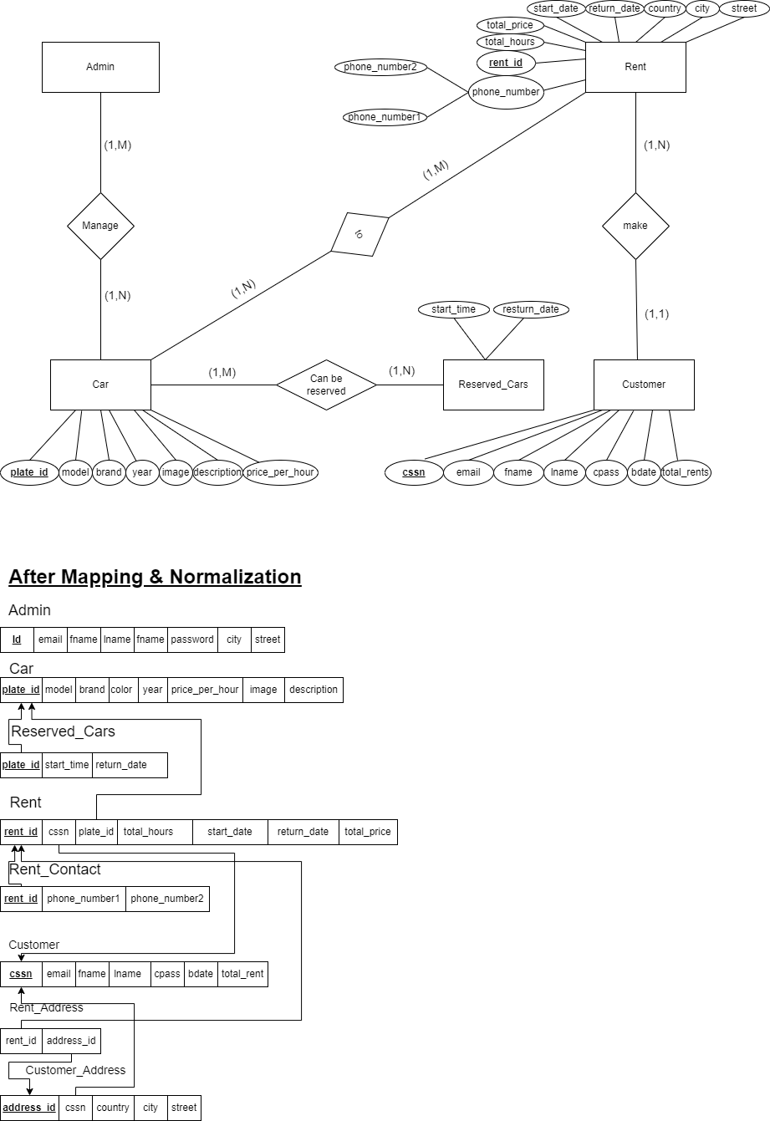

**DDL :**DROP DATABASE IF EXISTS car_rental_system;

CREATE DATABASE car_rental_system;

USE car_rental_system;

CREATE TABLE admin (

id INT(10) PRIMARY KEY,

email VARCHAR(255) NOT NULL,

fname VARCHAR(30) NOT NULL,

lname VARCHAR(30) NOT NULL,

password VARCHAR(255) NOT NULL,

city VARCHAR(200) NOT NULL,

street VARCHAR(300) NOT NULL

);

CREATE TABLE car (

plate_id INT(10) PRIMARY KEY,

model VARCHAR(100) NOT NULL,

color VARCHAR(100) NOT NULL,

brand VARCHAR(100) NOT NULL,

year INT(4) NOT NULL,

image VARCHAR(600) NOT NULL,

description VARCHAR(300) NOT NULL,

price_per_hour FLOAT(10, 2)

);

CREATE TABLE reserved_cars(

plate_id ,/INT(10) ,

start_time DATE NOT NULL ,

return_date DATE NOT NULL

);

CREATE TABLE rent (

rent_id INT(10) AUTO_INCREMENT PRIMARY KEY,

cssn VARCHAR(30),

plate_id INT(10),

total_hours INT(5) NOT NULL,

start_date DATE NOT NULL,

return_date DATE NOT NULL,

total_price FLOAT(10, 2) NOT NULL

);

CREATE TABLE rent_contact (

rent_id INT(10) PRIMARY KEY,

phone_number1 VARCHAR(12) NOT NULL,

phone_number2 VARCHAR(12)

);

CREATE TABLE customer (

cssn VARCHAR(30) PRIMARY KEY,

email VARCHAR(255) NOT NULL UNIQUE,

fname VARCHAR(255) NOT NULL,

lname VARCHAR(255) NOT NULL,

cpass VARCHAR(255) NOT NULL,

bdate DATE NOT NULL,

total_rent INT(4) NOT NULL

);

CREATE TABLE rent_address(

rent_id INT(10),

address_id INT(10)

);

CREATE TABLE customer_address (

address_id INT(10) AUTO_INCREMENT PRIMARY KEY,

cssn VARCHAR(30),

country VARCHAR(30) NOT NULL,

city VARCHAR(200) NOT NULL,

street VARCHAR(300) NOT NULL

);

ALTER TABLE rent_address ADD CONSTRAINT fk_rent_address_rent_id FOREIGN KEY (rent_id) REFERENCES rent (rent_id) ON UPDATE CASCADE ON DELETE CASCADE;

ALTER TABLE rent_address ADD CONSTRAINT fk_rent_address_address_id FOREIGN KEY (address_id) REFERENCES customer_address (address_id) ON UPDATE CASCADE ON DELETE CASCADE;

ALTER TABLE reserved_cars ADD CONSTRAINT fk_reserved_cars_plate_id FOREIGN KEY (plate_id) REFERENCES car (plate_id) ON UPDATE CASCADE ON DELETE CASCADE;

ALTER TABLE rent ADD CONSTRAINT fk_rent_cssn FOREIGN KEY (cssn) REFERENCES customer (cssn) ON UPDATE CASCADE ON DELETE CASCADE;

ALTER TABLE rent ADD CONSTRAINT fk_rent_plate_id FOREIGN KEY (plate_id) REFERENCES car (plate_id) ON UPDATE CASCADE ON DELETE CASCADE;

ALTER TABLE customer_address ADD CONSTRAINT fk_customer_address_cssn FOREIGN KEY (cssn) REFERENCES customer (cssn) ON UPDATE CASCADE ON DELETE CASCADE;

ALTER TABLE rent_contact ADD CONSTRAINT fk_rent_contact_rent_id FOREIGN KEY (rent_id) REFERENCES rent (rent_id) ON UPDATE CASCADE ON DELETE CASCADE;